8/11/2018

The idea behind our project is to demonstrate that if this technology were put into mass production, we’d be able to have a clearer insight into Britains healthy and unhealthy eating habits.

The use of mass data analytics is extensive. My research has cropped up a few examples that specifically stand out to me. The first one I came across is called “SelfieCity” by the DigitalThoughtFacility. SelfieCity takes 3200 photos from Instagram across Bangkok, Berlin, Moscow, New York and Sao Paulo[1] and displays them as a large visual data set. The website shows the data in different forms, always split by male/female and by each city, to visualise aspects such as how many of them smile compared to showing a more reserved facial expression. It also goes on to look at how some people tilt their heads more for example. In theory this kind of mass data can be used in correlation alongside other data and become very useful. For example they could look at the data and hypothetically say that on average people who aren’t smiling are more likely to tilt their head – from this they could then assume that when people are feeling negative emotions they tilt their head and this could be useful for research into technology such as facial recognition and sentiment analysis.

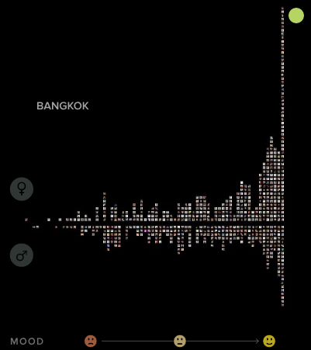[2]

As SelfieCity only has a limited amount of variants the way DigitalThoughtFacility have decided to lay out the data is very simple yet effective. It simply shows each separate city with female selfies above the line and males below. It then ranges from sad/moody looking images (left) to happier looking images (right). Although this is good inspiration for our project, the smart fridge will be collecting many more variants which means that although a display like this is effective, we may have to design a very different way of displaying our data. However the principles of this project in terms of the collection of data and displaying it all on a public site are very inspirational to our project, and the design offers a good basis to go by when thinking about how we might display our own data.

Another data set I’ve found is crime data within Plymouth City center. The data is all plotted onto a map to show where each crime took place, what it was registered as (e.g. anti-social behaviour, theft, sexual assault) and shows the date that it was registered. This is useful as it shows us what proportion of Plymouths crime goes on where. When used in correlation with other information such as the average income of people living in those areas, whether its mostly shops or houses, whether there’s nightclubs near by and so on, this could be useful in figuring out what is needed to tackle the crime. The main difference in this data set that I’m interested in is the visual design of how its presented. The data here is presented in “clusters” so for example it shows there were around 45 crimes in Royal Parade in 2018. When you click on the 45, the map will zoom in and divide the 45 into smaller circles, it will then do it again until eventually you’re zoomed in to an individual crime which then shows what category of offence it was with a date. This would be a practical inspiration point to base our design on as it involves GPS and is presented on a map. This is because linking back to the context behind our project we’re aiming to visually reveal how healthily the country is eating and reveal a few of our dieting habits. From this we’d be able to see which areas of the country eat what and when put into correlation with aspects such as the average income in these areas, food pricing, how rural they are etc it could reveal a lot about our eating habits as a nation and help to suggest how we can support healthier eating.

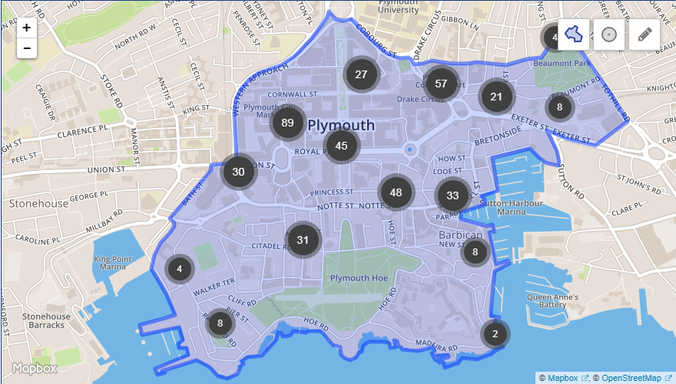[3]

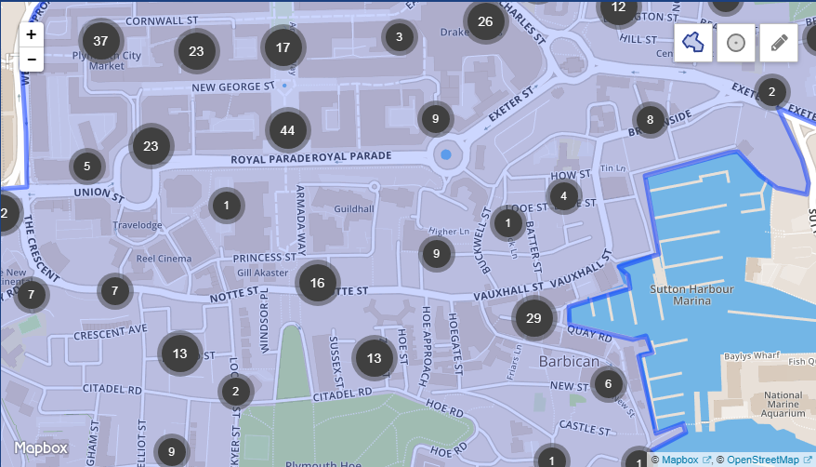[4]

1. http://selfiecity.net/#intro
2. http://selfiecity.net/#intro
3. https://www.police.uk/devon-and-cornwall/PLY.4028/crime/
4. https://www.police.uk/devon-and-cornwall/PLY.4028/crime/